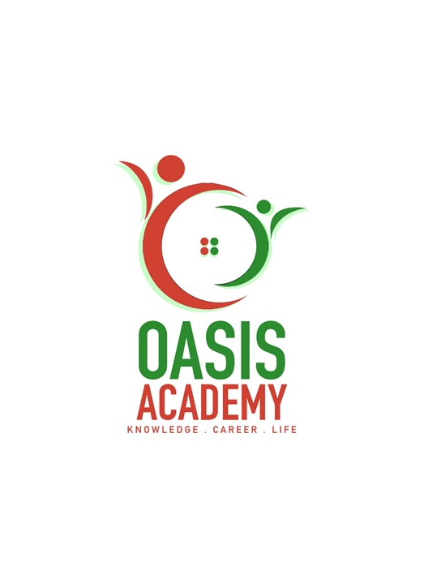

Name : KUMARARUBAN ADIRUBAN  
Login Id : kumararuban@oasis-portal.com  
Course Title: Accounting Fundamentals  
Subject Code : BHM03

**Submitted Date : 11.09.2017**

**Table Of Contents**

|  |  |  |
| --- | --- | --- |
| NO | DETAILS | PAGE |
| 1 | EXECUTIVE SUMMARY |  |
| 2 | INTRODUCTION |  |
| 3 | ASSIGNMENT QUESTION |  |
|  | PART 1 |  |
|  | PART 2 |  |
|  | PART 3 |  |
|  | PART 4 |  |
| 4 | CONCLUSION |  |
| 5 | REFERENCES |  |
| 6 | APPENDIX |  |

**1**

**Executive summary**

In the module, I covered the topic about The Tourism and Hospitality. In starting part, we can see the introduction of The Tourism and Hospitality. What is Tourism and Hospitality and how importance? In first part, I learned about the Tourism and Hospitality and explain my understanding about Hospitality industry. In the second part, I will brief about the difference type of Tourism categories and define the tourism. Third part I have understand the lodging accommodation and the types of Hotel accommodation. Finally, I will explain the Significant of Entertainment in this industry.



**2**

**Introduction**

Hospitality and Tourism is often described as 'the pleasure industry' or 'the welcome industry'. It’s an industry where communication is the key feature. It’s also an international industry and will involve a range of inter-cultural encounters. The language of this industry is quite clearly English in an international context, but it is also the language of meeting needs, of providing high levels of service, of understanding people, of delighting people, of solving problems.

From a teaching point of view the emphasis is firmly on functional language – giving information, making recommendations, dealing with problems and so on – and on creating realistic situational practice where language functions can be demonstrated and developed alongside basic service-oriented performance.



**3**

**ASSIGNMENT QUESTIONS**

**QUESTION 1**

**Define the Tourism and Hospitality. Explain your understanding about Hospital Industry.**

The industry of providing customer service to travelers or strangers. Hospitality professionals generally work in administrative or management positions in a service-based environment, and they are responsible for overseeing the operations and success of an establishment, such as a hotel or restaurant. The hospitality and tourism industry is diverse, and includes many locations including RV parks, food establishments, recreational facilities, campgrounds, boarding houses and youth hostels. While the overall goal of a hospitality professional is to ensure that guests and customers have pleasurable experiences, they can also be responsible for operations, such as hiring and training new staff; supervising office and financial administration; housekeeping, maintenance, and security staff; and marketing.

Hospitality professionals also distribute funds, set room rates, and ensure that the service standards of the business are met. General duties for hospitality professionals vary depending on the size of the business and the amount of staff available. In larger operations, there is usually a hierarchy of general managers, assistant managers, and supervisors who work to perform operational tasks relating to their areas of expertise. In a smaller business, the hospitality professional performs these tasks directly.

Sometimes hospitality professional positions are specialized. For example, some focus on managing the front office, while others can be responsible for convention services or financial administration. If a hospitality professional is employed in a specialized position, he or she must have excellent communication skills and the ability to work well alongside coworkers in other areas of the business.

Employers prefer applicants with a bachelor's degree in business or hotel or hospitality management, but a liberal arts degree along with hospitality experience may also be acceptable. Smaller establishments may accept applicants with a certificate or associate's degree in hotel, hospitality or restaurant management.

**4**

**Meaning of tourism**

**“**the temporary short term movement of people to destinations outside the places where they normally live and work, and their activities during their stay at those destinations”

It is the action and activities of people taking trips to a place or places outside to of their home community for any purpose except daily commuting to and from work . the term tourism now includes business travel as well as travel for pleasure. The tourism industry is the mix of interdependent businesses that indirectly serves the travelling public.

**Definition of tourism**

There are different purposes of visits:leisure,education,and business &special interest based on the purpose of visit,tourism is categorised into leisure tourism,cultural ,regional ,family and etc

**Meaning of hospitality**

the friendly and generous reception and entertainment of guests, visitors, or strangers

|  |  |
| --- | --- |
|  |  |

relating to or denoting the business of entertaining clients, conference delegates, or other official visitors.

**Definition or hospitality**

Hospitality is an industry that are closer to all the customers by giving them a customer service and entertaining them by their facilities.they also make others feel comfortable no matter what the situation might be.it includes sharing,respect,kindness and comfortable.

**5**

**QUESTION 2**

**Brief on different type of tourism categories. Define tourism.**

Traveling is one effective way to see the world, experience new cultures and meet new people at the same time. For many tourists, however, traveling accomplishes many other purposes that don’t even have anything to do with the joy of visiting a new place. This is why there are many different types of tourism that explain why tourists choose a particular destination and the things that they expect to do when they are there.

Perhaps the most common type of tourism is what most people associate with traveling: Recreation tourism. This is when people go to a place that is very different from their regular day-to-day life to relax and have fun. Beaches, theme parks and camp grounds are often the most common places frequented by recreational tourists.

If the objective of one’s visit to a particular place is to get to know its history and culture then this type of tourism is known as cultural tourism. Tourists may visit different landmarks of a particular country or they may simply opt to focus on just one area. They may also attend festivals and ceremonies in order to gain a better understanding of the people, their beliefs and their practices.

For tourists who want to see wildlife or bask in the joy of just being in the midst of nature, nature tourism is the answer. Ecotourism and nature treks are all part of this kind of tourism. Bird watching, for example, is one activity that nature tourists are fond of doing. What marks this kind of tourism is that it is environmentally responsible, has low impact and advantageous to the local community.

**Religious tourism** is another type of tourism where people go to a religious location or locations to follow the footsteps of their founder or to attend a religious ceremony. Catholics, for example, go on pilgrimages in the Holy Land to experience the paths where Jesus walked.

**Medical or health tourism** is a relatively new type of tourist activity where the main focus of the travel is improving one’s health, physical appearance or fitness. For instance, certain countries promote the expertise of their doctors and surgeons in the field of cosmetic surgery and invite foreigners to have their liposuction, facelift, nose lift and other forms of cosmetic procedures to be done there. Medical tourism also incorporates aspects of recreation tourism where the patient goes to a relaxing getaway to recover from the procedure.

**6**

**Adventure tourism** is another type of tourism that is catered for those who want to do more than just visit regular tourist sites. These kinds of trips involve challenging activities like rock climbing, mountain climbing and wild water rafting.

It should be noted that there are no strict delineations when tourists go on their trips. These kinds of tourism often overlap so it’s not unusual for travelers to experience more than one type of tourism in one vacation.

**7**

**QUESTION 3**

**Describe the lodging accommodation and types of Hotel accommodation.**

**Hotel** – Short term overnight accommodation.

**Resort** – Accommodation providing a wide verity of amenities and recreational facilities. It is more about the experience. Usually used for vacation or getaways.

**B & B** – Some sort of breakfast is included with your hotel night stay. They breakfast to range from a drink or coffee with a roll to a full breakfast.

**Home exchange or House Swap** – This is exchanging your home for another house for a set time period. This is often arranged through a travel service or club that you join.

**Apartment Rental or Flat** – Usually has a kitchen, sleeping area and bathroom not shared.

**Hostel** – Shared bedrooms & bathrooms (anyone they rent them to – no choice of roommates) Some hostels have private bedroom or bathrooms at an extra price. Mostly used by young single travelers.

**Pension** – Usually a family run Bed and Breakfast

**Motel** – Rooms usually open out to a parking lot. As the name implies it caters mostly to motorists.

**Lodge** – Usually out in nature, often made from logs, wood or other natural material.

**Yurt** – A domed portable tent usually covered in skins. It reminds me of a domed teepee. Usually used for accommodations out in the wilderness.

**Inn** – An inn is a small hotel usually either in the country or with a pub or tavern. A lot of the time they also have food available there.

**Campus or Dorm Room** – College room style usually twin beds or bunk beds.

**Capsule or Cube** – Small sleeping cube or capsule, nothing but a bed. There are usually a shared area with TV and bathroom

**Bungalow** – A small house or cottage is often called a bungalow. People call all kinds of houses bungalows so check to see what it really is.

**8**

**Villa** – Usually a country estate made up of several buildings or structures tied together. In some countries a villa could be just a vacation house or in other places a detached or semi-detached house.

**Extended Stay** – Usually more like an apartment that rents by the week or month.

**Resort** – Along with the hotel room will be common areas amenities such as a swimming pool, dining, game room, workout facilities, etc.

**Parador** – A luxury state-run hotel

**Guest House** – A house used to rent on a short term basis for travelers

**Unique Theme Accommodations** – Lighthouse, Cave, Ice Hotel, Railway Car, Underwater Hotel, Tree House, Dog House, House boat, Hotel with theme rooms, Castle, Cabin, Airplane Hotel, Utopia Bubbles

Depending on the country that we are traveling the names of the type of accommodation may change. There are many different choices when it comes to picking your vacation accommodations. Maybe next time look through this list and see if there is one you would like to try that you hadn’t thought of before.

**9**

**QUESTION 4**

**Explain the Significant of entertainment in this industry.**

**Question 4**

**Entertainments**

Entertainments in hospitality and tourism industries are facilities ,pools ,bars.

In all the tourism and hospitality industry mostly needs entertainments in their services because customers will get bored with their services later.entertainments are like karaoke,casino,parks clubs and more

**Five differents entertainments in hospitality industry**

**Marina**

The strength of marina is empathy,flexibility,being motivated,diverse experiences and the last education.the weaknesses are being too much concentrated on details,perfectionism.trying to please everybody.this are also should be changed in the marina .oppotunities they get is further education such as master seminars,training programs.further working experiences.and the last threads they will find is competing to others hotel school graduates,and also economic situations

**Sports**

Sports in hospitality industries are such as gymnasium,badminton courts swimming pools and more customers will feel entertained by this sports facilities in hospitality industry

**Cruise**

Some of the foreign customers will find to travel and finding other accommodations so we can make them happy by providing them cruise services

**10**

**Night clubs**

A night club is an entertainment place which usually operates late into the night.a night club is generally distingiused from bars, pubs or taverns by inclusion of a dance floor and a dj booths, where a dj plays recorded electronic musics,disco,hiphop,rock,pop,and other forms of dance musics

**Bars**

A bar is a retail business establishments that serves alcoholic drinks,beers,wine,liquors,andcocktails.for consumption on the premises

**11**

**Conclusion**

how much I have learned the basics of hospitality and tourism industry ; which is like can different between general purposes of it and its functions. And now I’m able to differences between the two industries hospitality industry and tourism industry . I also could be able to describe the difference of their importants to customers, such as entertainments,accommodations,facilitiesand more, as well as identify the main impotant and needs of the hospitality industry and tourism industry to the customers and their purposes.

**12**

**REFERENCCES**

<https://www.google.com/search?biw=1366&bih=638&tbm=isch&sa=1&q=bars+++in+hospitality+industry&oq=bars+++in+hospitality+industry&gs_l=psy-ab.3...384453.387703.0.388186.16.10.0.0.0.0.184.831.9j1.10.0....0...1.1.64.psy-ab..9.1.182...0i7i30k1.qQ45MltBSyk#imgrc=MBJqnRrWVrIX6M>:

<https://www.google.com/search?biw=1366&bih=638&tbm=isch&sa=1&q=night+clubs++in+hospitality+industry&oq=night+clubs++in+hospitality+industry&gs_l=psy-ab.3...212891.225962.0.226332.31.18.3.0.0.0.129.1518.14j4.18.0....0...1.1.64.psy-ab..13.2.217...0i7i30k1.Fai_B8nd0aY>

<https://www.google.com/search?q=entertainments+inhospitality+industry&oq=entertainments+inhospitality+industry&aqs=chrome..69i57j0.23377j0j7&sourceid=chrome&ie=UTF-8>

[**https://www.google.com/search?biw=1366&bih=638&tbm=isch&sa=1&q=sports+in+hospitality+industry&oq=sports+in+hospitality+industry&gs_l=psy-ab.3...119681.123767.0.124732.17.11.0.0.0.0.665.1584.4-2j1.3.0....0...1.1.64.psy-ab..14.1.663...0i7i30k1j0i7i5i30k1.yWyDXQb4iqM#imgrc=HXcZHET_XQocnM**](https://www.google.com/search?biw=1366&bih=638&tbm=isch&sa=1&q=sports+in+hospitality+industry&oq=sports+in+hospitality+industry&gs_l=psy-ab.3...119681.123767.0.124732.17.11.0.0.0.0.665.1584.4-2j1.3.0....0...1.1.64.psy-ab..14.1.663...0i7i30k1j0i7i5i30k1.yWyDXQb4iqM#imgrc=HXcZHET_XQocnM)**:**

[**https://www.google.com/search?tbm=isch&q=5+different+entertainments+in+hospitality+industry&spell=1&sa=X&ved=0ahUKEwic8YXJpprWAhUNT48KHSU1BZQQvwUIIigA&biw=1366&bih=638&dpr=1#imgrc=lZaOxqtql4wmtM**](https://www.google.com/search?tbm=isch&q=5+different+entertainments+in+hospitality+industry&spell=1&sa=X&ved=0ahUKEwic8YXJpprWAhUNT48KHSU1BZQQvwUIIigA&biw=1366&bih=638&dpr=1#imgrc=lZaOxqtql4wmtM)**:**

[**https://www.google.com/search?q=entertainments+inhospitality+industry&source=lnms&tbm=isch&sa=X&ved=0ahUKEwiWmPm6pZrWAhXHuY8KHaw7AbMQ_AUIDCgD&biw=1366&bih=638#imgrc=GX8EdzH_pmaLkM**](https://www.google.com/search?q=entertainments+inhospitality+industry&source=lnms&tbm=isch&sa=X&ved=0ahUKEwiWmPm6pZrWAhXHuY8KHaw7AbMQ_AUIDCgD&biw=1366&bih=638#imgrc=GX8EdzH_pmaLkM)**:**

**13**

[**https://www.google.com.sg/search?biw=1366&bih=638&tbm=isch&sa=1&q=tourism+industry&oq=tourism+industry&gs_l=psy-ab.3..0l2j0i67k1j0.152412.155431.0.156708.8.8.0.0.0.0.297.1573.0j3j4.7.0....0...1.1.64.psy-ab..1.7.1567...0i7i30k1j0i13k1.lwSqmlWKwpI**](https://www.google.com.sg/search?biw=1366&bih=638&tbm=isch&sa=1&q=tourism+industry&oq=tourism+industry&gs_l=psy-ab.3..0l2j0i67k1j0.152412.155431.0.156708.8.8.0.0.0.0.297.1573.0j3j4.7.0....0...1.1.64.psy-ab..1.7.1567...0i7i30k1j0i13k1.lwSqmlWKwpI)

[**https://www.google.com.sg/search?source=hp&q=meaning+of+hospitality&oq=meaning+of+hospitality&gs_l=psy-ab.3..0l4.3372.16009.0.17286.24.23.1.0.0.0.538.5078.0j9j6j4j1j1.21.0....0...1.1.64.psy-ab..2.22.5080...0i131k1j0i10k1.tAK79h85m-I**](https://www.google.com.sg/search?source=hp&q=meaning+of+hospitality&oq=meaning+of+hospitality&gs_l=psy-ab.3..0l4.3372.16009.0.17286.24.23.1.0.0.0.538.5078.0j9j6j4j1j1.21.0....0...1.1.64.psy-ab..2.22.5080...0i131k1j0i10k1.tAK79h85m-I)

[**https://www.google.com/search?q=what+is+the+tourism+and+its+important&oq=what+is+the+tourism+and+its+important+&aqs=chrome..69i57.47025j0j7&sourceid=chrome&ie=UTF-8**](https://www.google.com/search?q=what+is+the+tourism+and+its+important&oq=what+is+the+tourism+and+its+important+&aqs=chrome..69i57.47025j0j7&sourceid=chrome&ie=UTF-8)

**14**

**Appendix**

**Famous tourist spot in Singapore**

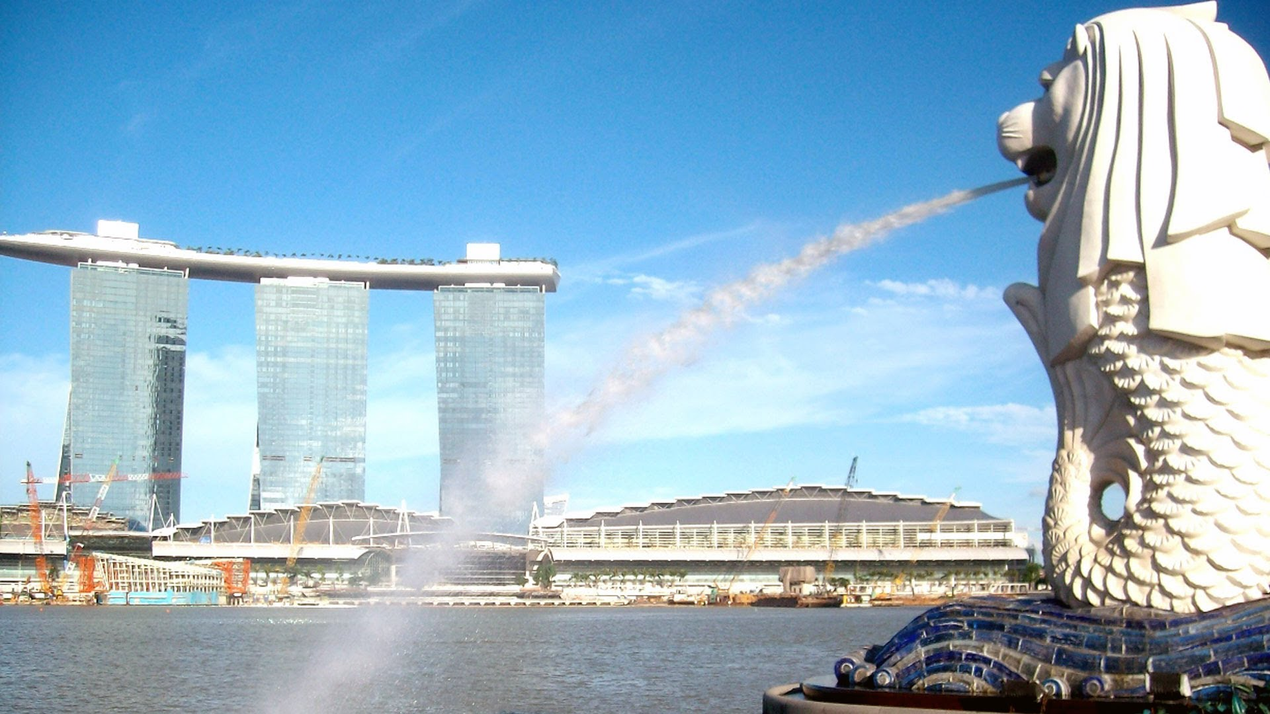

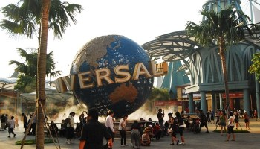

**15**

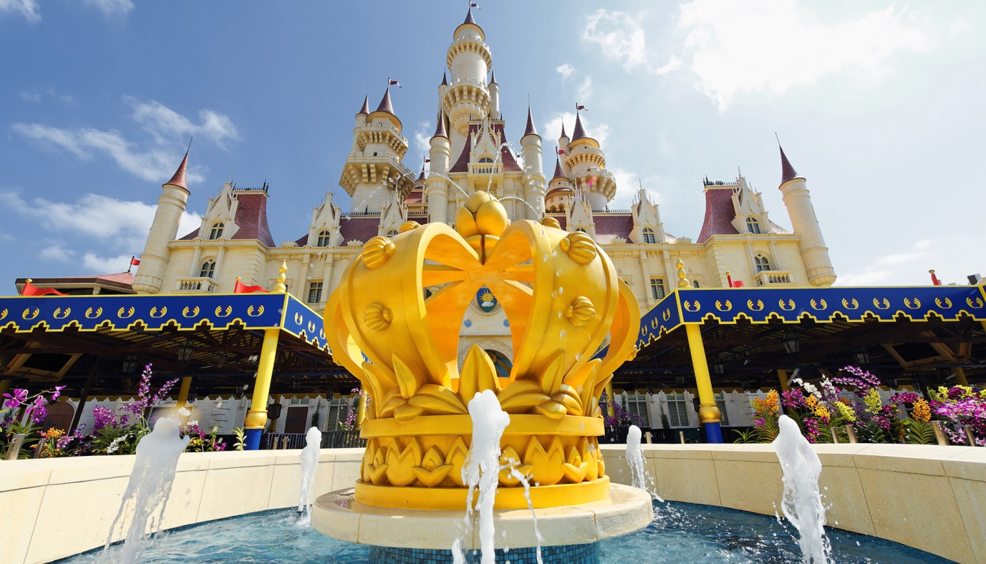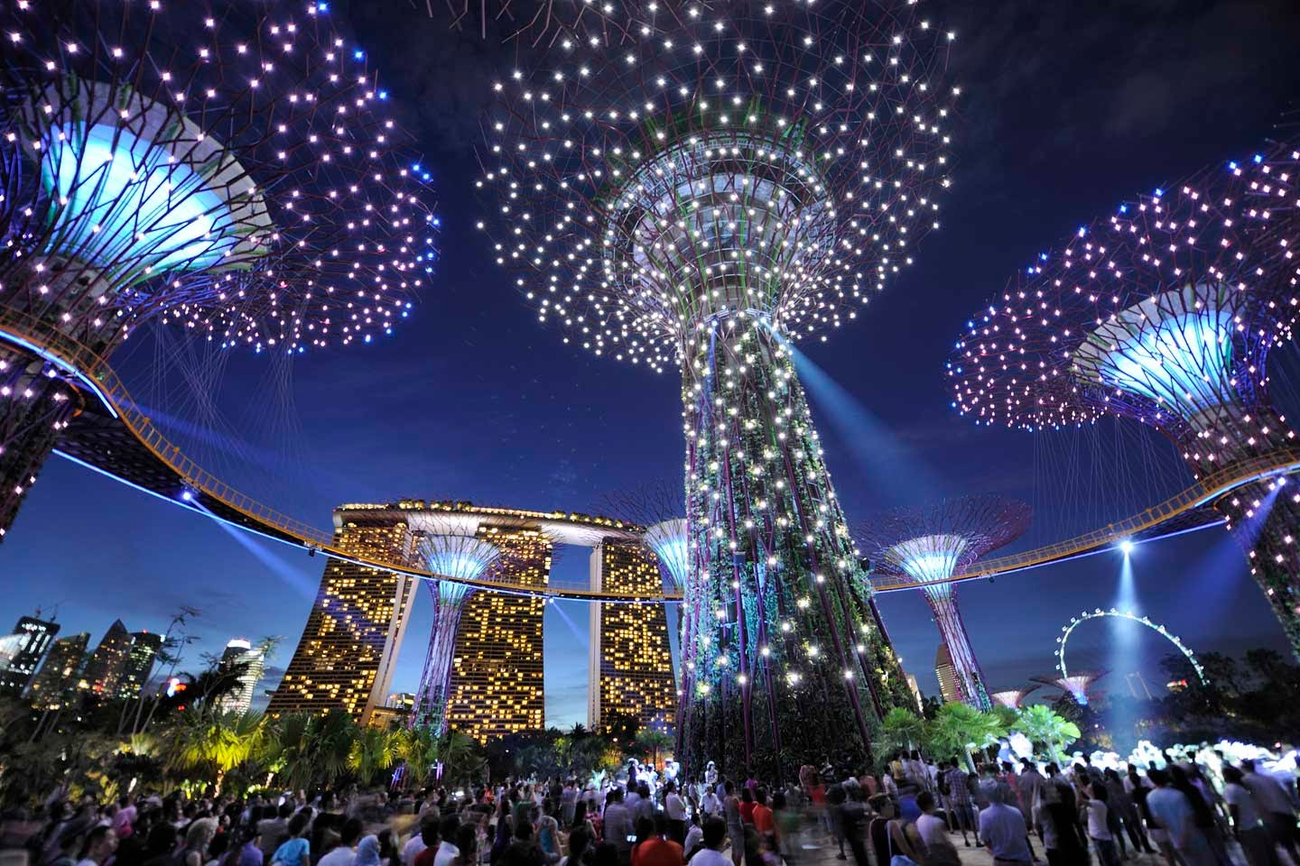

**16**